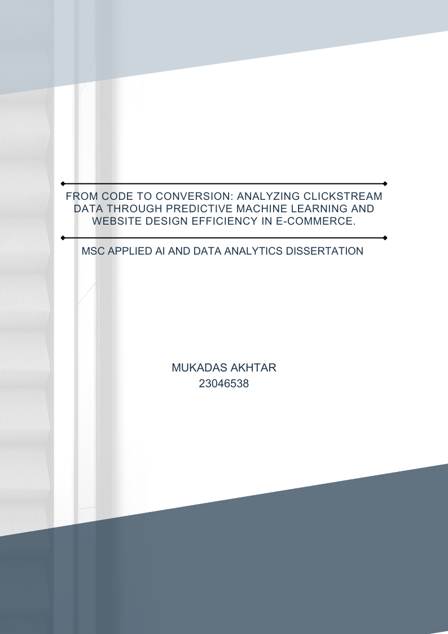

Table of Contents
Chapter 1: Introduction 4
1.1 Background 4
1.2 Problem Statement 5
1.3 Aims and Objectives 6
1.4 Research Questions 6
1.5 Significance of the Research 7
Chapter 2: Literature Review 8
2.1 Clickstream Data and its Importance in E-Commerce 8
2.2 Consumer Behaviour Theories in Online Shopping 8
2.3 Trends of purchasing in different months 9
2.5 Overall Design Efficiency 10
2.6 Machine Learning Models for Predicting Online Purchases 12
2.7 Challenges and Limitations in Clickstream-based Purchase Prediction 17
2.8 Identifying the Research Gap 18
Chapter 3: Methodology 19
3.1 Machine Learning Classification Model for Prediction of Purchases 19
3.1.1 Research Design 19
3.1.2 Data Source 20
3.1.3 Data Description 20
3.1.4 Preprocessing and Exploration of Data 22
3.1.5 Exploratory Data Analysis (EDA) 23
3.1.6 Logistic Regression 24
3.1.7 Decision Trees 24
3.1.8 Random Forest: 25
3.1.9 XGBoost (eXtreme Gradient Boosting) 25
3.1.10 Support Vector Machines (SVM) 26
3.2 Overall Design Efficiency 26
3.2.1 Feature Engineering 26
Chapter 4: Results and Findings 29
4.1 Descriptive Analytics 29
4.1.1 Monthly Purchases and Revenue Trends 29
4.1.2 Website Activities and Revenue 30
4.1.3 Types of Visitors and Purchase Patterns 31
4.1.4 Traffic Type Distribution 32
4.1.5 Weekends vs Purchase trends 33
4.1.6 Strategic Insights and Implications 33
4.2 Findings and Analysis of Machine Learning Model 34
4.2.1 Comparative Analysis of five different metrics 35
4.2.2 Random Forest: 36
4.2.3 XGBoost: 37
4.2.4 Support Vector Machine 37
4.2.5 Logistic Regression 37
4.2.6 Decision Tree 38
4.3 Findings of Overall Design Efficiency 38
4.3.1 Exit Rates vs. Informational and Administrative Pages 38
4.3.2 Exit Rates vs Product Pages 39
4.3.3 Page Values Across Different Page Types 39
4.3.4 Page Visit Distribution by Type 40
4.3.5 Breakdown of Page Visits by Purchase Behaviour 41
4.3.6 Visitor Type Distribution 42
4.3.7 New Insights after Feature Engineering 43
4.4 Justification and Discussion 45
4.4.1 Purchase Prediction Model 45
4.4.2 Overall Design Efficiency 46
Chapter 6: Recommendations and Challenges 48
6.1 Recommendation on findings 48
6.2 Recommendations for Future Research 50
6.3 Challenges 50
Chapter 7: Conclusion 51
7.1 Contribution to Literature 52
Appendix 59
Research Proposal 59

Acknowledgement
Firstly, I would like to thank God Almighty who has been so kind to me and for bringing me till here. This dissertation represents a deeply enriching journey, one that would not have been possible without the unwavering support and guidance of several remarkable individuals.
I extend my heartfelt gratitude to my supervisors, Dr. Shahid Rasul and Dr. Irfan Mehmood, whose expertise not only shaped this research but also significantly enhanced my understanding of the subject matter through their constant readiness to help whenever needed.
I am forever grateful to my parents and my sisters for always believing in me, and their constant love and sacrifices that have been a bedrock throughout this journey.
Special mention to my Aunty, without whose support and love I would not be here at all.
I am equally grateful to all my teachers and colleagues. Your support, feedback, and belief in me have enriched this experience more than words can say.

Chapter 1: Introduction

1.1 Background
E-commerce businesses are increasingly gaining popularity with more customers shifting to online shopping in today’s world of digital innovation. This is pushing retailers to use cutting-edge technology and data-driven strategies to stay competitive in the market. The e-commerce clickstream data generated by platform systems is one of the largest underutilised data sources in this industry. Clickstream data is produced by online user browsing activities and captures all website movements, including page visits, link activations, and session durations. (Bucklin and Sismeiro 2009) This data makes consumer interactions and preference evident, allowing businesses to understand the customer purchasing decisions better.



Figure 1. Collecting clickstream data of online customers for prediction. (Selerity, 2020)

The use of machine learning (ML) techniques has grown in importance as a means of finding patterns in large datasets, including data from e-commerce. User clicks show signs of interest and the main objective for retailers is to convert those clicks into completed transactions. Even with the abundance of data resources and analytical tools available, many e-commerce companies still have trouble identifying customers who are willing to make a purchase. By combining powerful machine learning algorithms with rich clickstream data inputs, retailers can optimise personal marketing and improve the overall websites performance.
There is a major difference in the effectiveness of advertisements if they are personalised. Targeted advertisements after analysing user’s clickstream data generated double the traffic on the website as compared to non-targeted users. Moreover, a survey revealed that 49% of customers claimed they would like to shop again with a retailer if their first experience was specifically tailored and personalised to their needs. Conversion rates and revenue increased by almost twice the amount after targeted advertisements were implemented in research. (Sakalauskas and Kriksciuniene 2024).
These insights show how important targeting advertisements and personalised recommendations is for online retailers as it can double their revenues. This is where clickstream data of website users is useful. Online retailers can collect their customers clickstream data and convert it into actionable insights for targeted marketing.

1.2 Problem Statement
Although e-commerce websites gather large amounts of clickstream data daily, they find it difficult to use this data or to implement it to their benefit. This is because they are unsure of how to create reliable buying prediction algorithms, which predictive machine learning techniques would provide the highest reliability, in addition to which variables in that data hold the most importance for them. Retailers lose out on better business prospects and consumer satisfaction suffers from the absence of precise prediction and personalisation technologies.

1.3 Aims and Objectives
The primary aim of this research is to conduct a comparative analysis of various machine learning models to predict e-commerce conversions using clickstream data and to carry out an overall design efficiency analysis of website being studied. In doing so, it seeks to:
- Use performance metrics, specifically Accuracy and F1-score metrics to compare the predictive performance of five different Machine Learning algorithms.
- Identify which clickstream features are the most important in determining purchase decisions, which will provide retailers with actionable insights for website optimization.
- Investigate how different months, occasions, economic conditions, and other external factors influence the predictive accuracy and stability of the models.
- Examine how targeted marketing and personalization’s can be optimized by predictive analytics derived from clickstream data.

1.4 Research Questions
This study is guided by four key research question, which will help reach the aims and objectives:
- Which machine learning algorithm provides the highest accuracy and F1-score in predicting e-commerce conversions using clickstream data?
- Which clickstream metrics are most predictive of an e-commerce purchase?
- How do external factors such as seasons, occasions, or economic conditions influence the predictability of e-commerce purchases?
- Can AI-driven personalization (e.g., product recommendations) be optimized using clickstream prediction models?

1.5 Significance of the Research
The results of this study are useful for all types of businesses, especially the retail sector. The findings of the study will give retail companies insights about their customers, and it will help them better predict their website users’ needs by combining machine learning models with key metrics. With this information, businesses can more effectively allocate their marketing budgets while developing customised site layout options, promotions, and product suggestions for different user segments.
Additionally, decision-makers can strategically modify marketing campaigns by having better knowledge of how variables like seasonality impact conversion trends. Retailers can predict increases or decreases in customer demands by planning promotions or modifying inventory. Lastly, the findings from the study will aid in the development of future advances in AI-driven e-commerce personalisation tactics. Retailers may provide targeted recommendations by combining predictive modelling with sophisticated recommendation systems, which results in satisfied and loyal consumers. As the internet market becomes more competitive, online retailers gain a significant competitive edge by being able to extract valuable information from clickstream data. Therefore, beyond its academic scope, the research yields useful outcomes that direct retail operations and foster the development of future e-commerce system innovations.

Chapter 2: Literature Review

2.1 Clickstream Data and its Importance in E-Commerce
In this age of digitalization, online purchasing has increased significantly. A survey in 2024 revealed that 29% people worldwide used marketplaces to shop, 28% used physical stores and 10% used websites to shop in that year (Chevalier 2024). This is a major shift in consumer patterns and to benefit from it, this shift should be studied and understood in detail.
This is where clickstream data and its useful analysis will be beneficial. Clickstream data is all the information about how a customer browsed on a website as in one single session, a user clicks on multiple pages, buttons and links and a collection of all these decisions is the clickstream data. It can be collected on the server log files as the customer is navigating or sometimes the analyst or research needs to collect it themselves. This data can also distinguish if a user is first time visitor or a returning one through the IP address and Cookie ID. (Bucklin and Sismeiro 2009)
Till almost 1980, consumers were studied as rational beings and so their purchasing behaviour was studied using methods of logic and reason. However, these perceptions changed to how consumer behaviours were more influenced by things like their emotions, advertisements they see, and how the emotional part of brain, the right hemisphere, is also involved in this process. (Leonov et al. 2023)

2.2 Consumer Behaviour Theories in Online Shopping
A study on customer purchasing behaviours was conducted using the “Theory of Planned Behaviour” of Azjen from 1991.It found out that people who had a high “self-efficacy”, have more confidence in their abilities to navigate a website and buy from it, are more likely to purchase from it. Moreover, people are also influenced by the attitudes of people around them about online shopping. So how a person behaves, it shows their intention. (George 2004). Therefore, session attribute data can be used to find out, for example, if a customer revisits frequently but is not buying, the theory of planned behaviour claims that they have a positive intention to buy but there are certain factors stopping them, which can then be addressed through marketing and increase sales.
Another theory that resonates with the clickstream data and its usage is the Technology Acceptance Model (TAM) from 1986 by Davis. This theory believes that a technology systems use, and acceptance comes from factors like how useful people think it is and how easily you can use that system. The ease-of-use factor is called “Perceived ease of use (PEU)” which measures the ease and comfort customers feel using the technology and “Perceived Usefulness (PU)” in TAM is when customers use a technology if they think how they are currently doing things can be improved. (Natasia et al. 2022)
In this case scenario, it will mean that if the website loads quickly, navigation is easy , a clear organised layout, customers are going to use it more.If a website helps users locate products they want quickly and lets them easily complete the buying process at home rather than going through the whole process of going out to buy that product, it will be better received. Technology Acceptance theory helps us understand how important website design and efficiency is.
Lemon and Verhoef in 2016 came up with a great model that tracked the lifecycle of a customer, from Pre-purchase to the Purchase and finally post-purchase. This paper focuses on the first two stages, as that is where clickstream data is beneficial. With the clickstream data of those customers during the “pre-purchase”, we can convert that to a “purchase” using personalised offers, easy checkouts, and personalised recommendations. To do that, there needs to be a certainty which customers are more likely to purchase.

2.3 Trends of purchasing in different months
Seasonal trends and months are a big influence when it comes to the retail sector. Sales can fluctuate greatly depending on months and usually the trends stay the same. To study this, monthly trends of retail shopping from 2022 to 2023 were studied. (Office for National Statistics (UK) 2024)
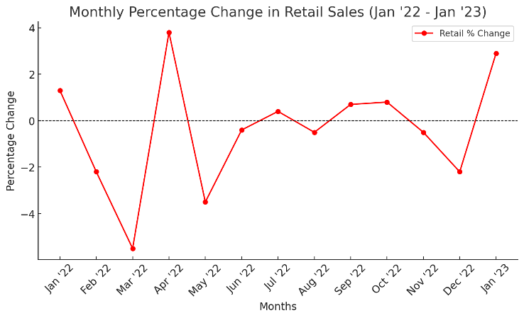

Figure 2: Monthly Percentage Change in Retail Sales Jan '22 to Jan '23

The graph in Figure 2 was created using data from Office for National Statistics (UK).
Sales fell from January till March and then took a sharp positive turn in April. April was the busiest month after which there a massive decline in May. The rest of the months from June to December, there were slight changes, but sales stayed moderate.
Research has been conducted to find the link between sales and factors like seasons, weather, or if it’s a special occasion. Sales are high when weather is cold and low when its hot outside. When its usually hot, people switch from shopping in stores to online shopping. (Gallino et al. 2019)

2.5 Overall Design Efficiency
Groth and Haslwanter have compared responsive and adaptive designs of mobile tourism websites which would increase its usability. According to the research’s-controlled user-based testing, responsive websites perform better when it comes to efficiency. The study indicates that while the user experience is the same for responsive and adaptive designs, responsive designs perform better when used on mobile devices. Although the study offers helpful practical information, the general validity of its findings is limited due to a small sample size and focus on tourism websites. More studies in different disciplines and studies with larger participant groups might improve the study validity. (2015)
The exploration of user behaviour continues with another article examine real-time user online surfing activity using a "think-aloud" protocol to comprehend the implications website design has. They prove through their analysis that a system that has easy to access content, simplified information, and clear navigation is necessary for users to have a good experience. The study found that when users find the navigation of a website easy to use, they are more likely to stay engaged and complete activities. Although the qualitative approach provides a deep insight of the user experience, its conclusions are nevertheless limited because they are based on a small unrepresentative user group whose behaviour may have been influenced by observation. (Tan and Wei 2006).
Shifting focus to performance metrics, Auger analyses the relationship between interactive elements, site complexity, and website operational outcomes in this paper. There is no clear correlation between increased traffic or user engagement and visual design elements. This study is helpful to small businesses because it confirms that meaningful interactive features are more effective than just making a websites aesthetic appeal. The study's cross-sectional strategy limits its capacity to provide long-term insights because it analysed medium to small-scale retail websites. (Auger 2005)
Gaur et al. uses a more advanced Fuzzy DEMATEL model for website efficiency factor evaluation of Indian Retail Websites. To address bias and comprehend the intricate links between usability, content quality, and service responsiveness, this study used fuzzy logic. In addition to offering design suggestions for retail website developers, the analysis produces a series of important criteria that impact website performance. The results are less applicable to other market contexts because they mostly deal with Indian retail websites, and the inclusion of expert judgements introduces subjectivity in the analysis. (2020)

2.6 Machine Learning Models for Predicting Online Purchases
Now moving to the power of data and machine learning in enhancing online customer experience, we have the paper by Gupta and Joshi. Their paper talks about how machine learning model of predictive analytics is used in marketing. They focus on how these models can help businesses identify customers who are likely to churn and then convert those in sales using personalisation’s and efficiently targeted marketing techniques.

Study Reference | ML technique | Research Objective | Methodology | Key Findings | Critical Analysis
Borja Requena et al., 2020 | Feature-based classification and Deep learning (LSTM architecture) | Predict user purchase intent from minimal clickstream data | Compared k-gram statistics with visibility graph motifs and developed LSTM architecture | Both approaches achieved reliable purchase predictions, but LSTM outperformed previous models. | Offers good interpretability but can miss out on complex patterns. The LSTM network tracks temporal connections, although it needs more inputs and processing power.
Nitta et al. 2021 | Graph-based machine Graph Neural Network (GNN) | Improve prediction of student dropout in MOOCs by modelling learner behaviour | Use GNNs to find patterns in clickstream data and test performance against basic classifiers | Graph Neural Network performed better than traditional models in predicting dropouts | Needs high computational power and excellent quality data with precise session limitations and timestamps.  Harder to explain and interpret than Decision trees and Logistic regression.
Kashyap and Nayak 2018 | Decision Tree (DT)  Random Forest (RF)  Naive Bayes (NB)  Support Vector Machine (SVM) | Comparison and evaluation of machine learning models in predicting student dropouts | Applied and evaluated classification models to predict whether a student would drop out or complete the course | Random Forest achieved the highest prediction accuracy | RF computationally costly and harder to interpret.  Decision Tree is interpretable but may be overfit with complex data.
Zavali et al. 2023 | Cluster Analysis with k-means clustering and hierarchical clustering | Identify consumer segments based on clickstream data | Analysed clickstream data to reveal shopping behaviours | Identified distinct consumer segments | Applied clustering analysis to historical dataset so fails to explain how this method could be used in systems with continuous user behaviour.
Zhili Zhang et al. 2005 | Online Support Vector Machine (SVM) | Predict user navigation patterns on a website in real-time without requiring complete retraining of the system. | An Online SVM model and Multi-class Online SVM by using log files from three sources. | Reached similar accuracy levels as traditional SVM while training being faster. | Challenging for stakeholders who require easy-to-understand explanations as difficult to interpret such models.
Cheng-Ju Liu et al., 2020 | Logistic regression XGBoost | Predict repurchase behaviour on e-commerce platforms | Analysed customer behaviour data and compared linear and nonlinear models | Nonlinear models like Boost provided better predictions | XGBoost effectively handles complex patterns but may overfit if not tuned well.
Koehn et al. 2020 | Recurrent neural networks (RNNs) : LSTM (Long Short-Term Memory) GRU (Gated Recurrent Unit) | Deep learning predictive model which forecasts user purchase behaviour from website clickstream actions. | Neural Network’s performance better than standard machine learning as per Accuracy, Precision, Recall and F1-score metrics | Product-related click rates combined with session duration length were the best indicators of purchase intent. | The DNN detected non-linear patterns but operates as a black box which makes marketers and UX team’s struggle.
Oualid et al. 2024 | Descriptive and Correlation analysis on data from 70 online stores and customer feedback. | Assess the effect of content personalization on customer engagement | Evaluated customer engagement metrics in personalized content scenarios | Content personalization positively impacts customer engagement | No use of machine learning techniques or regression modelling so lacked deeper insights.
Carmona et al. 2012 | Clustering (K-Means)  Association Rule Mining  Sequential Pattern Mining | Studying website visitor behaviour using web usage mining techniques | Collected clickstream data for the website for 1 year using Google Analytics | Found products which were complementary which led to enhanced recommendation systems. | Simplistic as compared to deep learning models which perform sequence prediction modelling at a better level.
Haider and Yesilada 2022 | Convolutional Neural Networks (CNN)  Gradient Boosted Decision Trees (GBDT)  Logistic Regression  Support Vector Machines (SVM) | Differentiate between layout tables for visual design and relational tables for data organization by displaying visual representations instead of HTML source code. | Convolutional Neural Networks trained through images which enables them to classify tables based on their appearance. | The CNN model is superior when compared to models that used HTML features as input. | High computational cost as compared to HTML-based analysis.
Zhang 2025 | XGBoost (Extreme Gradient Boosting) | How effective XGBoost based predictive models are in e-commerce | XGBoost compared to Random Forest, Decision Tree, and Logistic Regression | Model performance evaluated by classification metrics and XGBoost outperformed. | XGBoost valuable when performance more important than understanding model decisions, as simple models would better explain customer decisions.
Chen 2020 | Long Short-Term Memory (LSTM) Neural Network  optimized using Adaptive Genetic Algorithm (AGA) | Build a prediction model for online retail sales using a deep learning approach | Time-series transaction data taken from online retail website and model's performance compared to the basic LSTM. | AGA-LSTM model achieved lower errors compared to standard LSTM and traditional techniques. | AGA-LSTM uses heavy power and there is a higher chance of overfitting if regularization or early stopping isn’t carefully applied.
Gupta and Pathak 2014 | Logistic Regression and K-means clustering algorithm | Prediction system that determines customer behaviour and effect on buying choices. | Real-time prediction of purchases so that dynamic pricing strategies can be implemented | Could target price-sensitive customers and adjust offers better using clustering with predictive modelling | The paper doesn’t mention performance metrics like accuracy, ROC-AUC, or F1-score, so hard to evaluate model
Table 2.1 : Previous studies
Many machine learning models have been built to analyse clickstream-based user behaviour and prediction. One of the most used techniques for handling time-based data using deep learning techniques is the Long Short-Term Memory (LSTM) model. It is an artificial neural network which works on keeping memory and this model has performed exceptionally well in language processing models like chatbots, speech to text, and translations. (Tufail et al. 2023) Borja Requena et al., Koehn et al., and Chen used LSTM as their research model. Studies have shown that LSTM outperforms earlier models and demonstrates great capabilities in time-dependent behaviour modelling. But, significant computing power is needed to develop LSTM models. Moreover, organisations looking for clear explanations of the behaviour have challenges since LSTM models function as "black boxes," making it difficult to grasp the results.
Secondly, the Graph Neural Network (GNN), which is a deep learning advanced model specifically used for graphical data, has been used in much research. (Tufail et al. 2023) Nitta et al used the GNN approach to predict dropping out from online courses. The results of the study showed that GNN was better than traditional techniques at recognising patterns in student behaviour. The problem with GNN is that it requires h high-quality, well-organised data with accurate timestamp information. Because GNN models require expensive computer platforms to function and are challenging to interpret, they are subject to the same restrictions as LSTM models.
Kashyap and Nayak's research used standard machine learning models, such as Random Forest (RF), Decision Trees (DT), and Support Vector Machines (SVM). Although Random Forest produced the most accurate findings, its interpretation was still difficult and required more processing power. When working with complicated data structures, decision trees were prone to overfitting. Although SVM has been used in several research, such as Zhili Zhang et al., which show its excellent performance and quick adaptability, experts find it difficult to interpret its findings.
Furthermore, Cheng-Ju Liu et al. and Zhang's(2025) testing of the XGBoost algorithm produced positive findings . The researchers found that the model handled complex interactions well and that predictions were highly accurate. However, If XGBoost's parameters are not correctly optimised, its performance declines and it overfits. Business teams might find it challenging to understand the model's output because it offers little information into its prediction techniques.
The primary forecasting technique used in the research publications by Haider and Yesilada, Gupta and Pathak, and Cheng-Ju Liu was Logistic Regression. This model is good to start the analysis because its quick and is still simple enough to understand, but when dealing with data that has complex pattern structures, the model performs poorly.
Koehn et al. used Recurrent Neural Networks (RNNs), including GRU and LSTM, in his prediction model for online shopping .RNNs work on the “Feed-forward neural network” and it has good capacity to deal with sequential data like time-series data. (Tufail et al. 2023). Although, these models are like black boxes with hard to interept results, they recognize patterns better than the basic models
Another model used by Haider and Yesilada was the Convolutional Neural Networks (CNN) model to detect and classify different table types on websites. (2022). CNN takes images as their inputs and it works best in problems of classifying features in an image, therefore it was a good choice for Haider and Yesilada’s study. CNN is a form of supervised leaning and its main strength is accurate feature extraction. (Tufail et al. 2023).
Some well-known Clustering algorithms are K-Means and Hierarchical Clustering, which were used by Zavali et al., Carmona et al., and Gupta and Pathak. It is unsupervised machine learning, and it divides the unlabelled data into groups based on similar attributes. K- means is simple and uses less computation power (Tufail et al. 2023). The existing approaches are ineffective for real-time systems, and they are unable to predict future activities. The lack of cluster quality evaluation measures in Zavali's study reduced the reliability of the study's findings.
Carmona et al.'s Association Rule Mining and Sequential Pattern Mining technique showed how to identify clusters of frequent product selections. When you compare new approaches, like deep learning for user prediction, the simple basic models produce constrained results.
Chen's study used AGA-LSTM as a hybrid model that combined LSTM with Attribute Guided Data Augmentation(AGA) to achieve better results. More processing power and careful parameter selections were required for Chens model, but it produced good predictions.

2.7 Challenges and Limitations in Clickstream-based Purchase Prediction
Selection of the model for the relevant problems remains a major problem as factors like overfitting, cost, robustness, computational power and complexity. The more complex model is chosen, the costs and training periods increase. There are some techniques that can be used to select the best fitted model according to the nature of the problem. It tries to find a balance between complexity and how good the model fits to the question. Some of these techniques are Akaike Information Criterion (AIC), Bayesian Information Criterion (BIC) and Minimum Description Length (MDL).The first two techniques take into account the parameters, number of samples, and choosing a model on “the sum of model complexity and data encoding length”.
Another problem in the prediction machine learning models is the lack of available data. Most times the problems in volve data which involves people information which can be sensitive or not legal to use or gather. (Tufail et al. 2023). When clickstream data of people is collected, it becomes a concern of privacy and consent to collect a visitors’ information as they navigate a website, just so products are matched to them so businesses can benefit. (Baumann et al. 2018). Different countries have different regulations concerning collecting data of website users.The Europen Union has a regulation of asking users about cookies and their data settings preference before they start browsing. Data of visitors who do not have an account or have not logged in is collected without revealing their identities. (Baumann et al. 2018)
Data can also be missing, which can be due to server or storage problems in the system. This problem can be solved by methods like Long Short-Term Memory.

2.8 Identifying the Research Gap
Clickstream predictive modelling research has grown significantly, still several crucial gaps can be detected from the past literature. Previous research have handled data in batches, which hinders their ability to analyse real-time data and predictions. The application of these models for real-time decision-making is limited by these constraints. Deep learning processes increase precision at the expense of interpretability, making access to prediction insights difficult. When it comes to using these predictive models in marketing, these studies do not provide any actionable recommendations or insights that can be applied using their research results. This paper addresses those problems by implementing strategies that improve model prediction clarity, allow for real-time decision-making, and provide relevant marketing recommendations from the predictions.

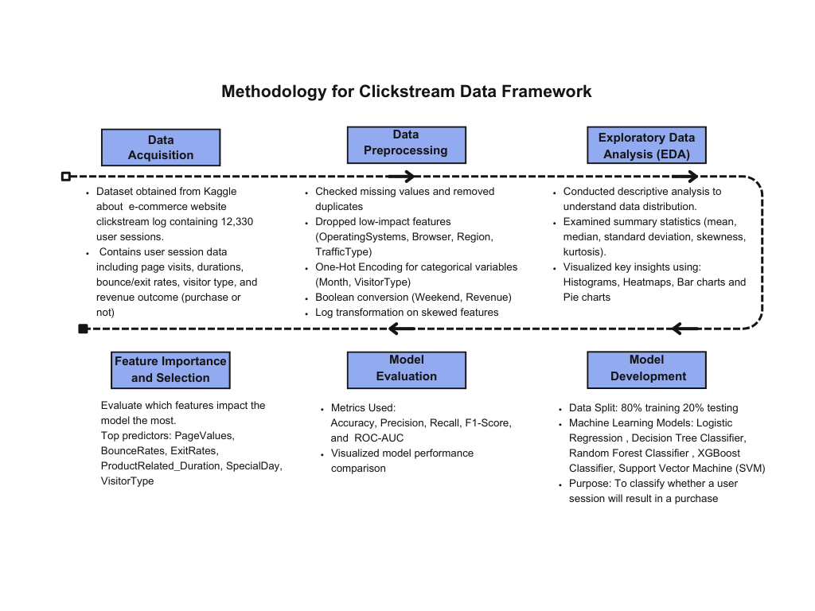
Chapter 3: Methodology
Figure 3.1 Methodology Framework.

3.1 Machine Learning Classification Model for Prediction of Purchases

3.1.1 Research Design
This paper uses a mixed-method approach with quantitative and qualitative features in it. In the first part of each chapter, the machine learning classification model is discussed and then the website overall design efficiency.
- Machine Learning Classification:
A machine learning model is used to predict whether a user navigating the website will purchase something or not. Different algorithms are tested, and the model’s performance is measured using multiple metrics like accuracy and precision.
- Overall Design Efficiency:
In the second part, the study looks at the overall design of the website, using descriptive analytics. This involves selecting and creating specific features that measure how effective the design is. The primary goal here is to find design related elements on the website that shapes a user’s experience and then suggest how it can be improved.

3.1.2 Data Source
The dataset “Online Shoppers Purchasing Intention” used for this dissertation study was taken from Kaggle. Kaggle is a well- renowned website, with datasets from credible sources. Kaggle sourced the dataset from an article written in an international well-reputed science and research journal called “Neural Computing and Applications”. Each article in this journal is checked for credibility by two experienced people in that field. This dataset is taken from the article “Real-time prediction of online shoppers’ purchasing intention using multilayer perceptron and LSTM recurrent neural networks”. While the author of this article creates a prediction model using neural networks, this dissertation main focus was to do a comparative analysis of different machine learning models and check how accurately each model predicts
Link of the article:
https://link.springer.com/article/10.1007/s00521-018-3523-0#citeas
Link of the dataset:
https://www.kaggle.com/datasets/imakash3011/online-shoppers-purchasing-intention-dataset/data

3.1.3 Data Description
The dataset is from an online bookstores website database, containing 12,330 individual user’s clickstream data. It contains information about each user’s interaction on the website, their device and region details. The website uses osCommerce platform, so a C++ code was used to track and retrieve the browsing information of the website viewers. (Sakar et al. 2018)
Variables | Description
Administrative | Number of Administrative related pages visited
Administrative_Duration | Time spent on Administrative pages
Informational | Number of Information related pages visited
Informational_Duration | Time spent on Information pages
ProductRelated | Number of Product related pages visited
ProductRelated_Duration | Time spent on Product pages
BounceRates | % of visitors who enter and leave the website from the same page, without taking any further action.
ExitRates | % of page views that were in the last session
PageValues | Average value of a page a user viewed prior to completing an online purchase.
SpecialDay | Site visits closeness to any special day like Mother’s Day, Valentine's Day etc. Value calculated according to when an order is placed and delivered
Month | Month in which website visited
OperatingSystems | Operating system used by the visitor
Browser | Browser used by the user
Region | Geographic location of user
TrafficType | Type of Traffic
VisitorType | Type of visitor i.e New visitor or Returning Visitor
Weekend | Weekend or not when user visited
Revenue | Whether the session led to a purchase or not
Table 3.1 : Description of the dataset

3.1.4 Preprocessing and Exploration of Data
The data was stored in an Excel file so the data loading process started by specifying the file path and using pandas to create an ExcelFile object. From there, the function “pd.read_excel” was used to read the data into a pandas DataFrame. After this, an inspection of the dataset was done to confirm that the correct columns, data types, and row counts are uploaded before proceeding with feature engineering, transformations, and modelling.
The first stage of data preparation was a prerequisite for transforming the dataset before the start of the machine learning modelling. There were four primary steps in the preprocessing procedure:
- Checking Missing Values:
Examining the dataset revealed that there were no missing value data points. By ensuring that all data points were present, the completion check eliminated the need for data imputes and preserved the integrity of the original information quality.
- Low-impact Features Dropped:
Using correlation analysis, operating systems, browsers, regions, and traffic types were eliminated from the analysis. These removed variables improved operational performance while reducing the model's complexity and disruptions.
- One-Hot Encoding:
One-Hot Encoding was applied to the categorical variables of Month and VisitorType. This data conversion improved the categorical data's interpretability, which enhanced the prediction outcomes.
- Log Transformation:
The skewness problem in the numerical features of ProductRelated_Duration, Informational_Duration, and PageValues was resolved via log transformation. The data distributions became more symmetrical because of this normalisation technique,
and the model's stability increased as skewness decreased.

3.1.5 Exploratory Data Analysis (EDA)
EDA was carried out to understand the features of the dataset. The key insights were then visualised using:
Method of Data Visualisation | Explanation
Bar Chart | Used to visualise categorial data like ‘VisitorType’ and ‘Month’ to easily distinguish between categories and patterns.
Pie Charts | Binary categorical features like ‘Revenue’ and ‘Weekend’ visualised in pie charts for a clearly identifying distribution in the dataset.
Heatmaps | Heatmaps used to visualize relationships between numerical variables. This allowed identification of related important variables, like page vales, bounce rates and exit rates.
Histograms | Used to identify outliers and assess distribution of numerical variables like page durations.
Table 3.2 : Summary of Data Visualizations used in the research and their justification

These visualizations provided a number of significant conclusions and insights into what direction this study could take and the next modelling phase. The Python libraries of pandas, matplotlib and seaborn were used in the coding of the model. 'PageValues', 'BounceRates', and 'ExitRates' were among the model attributes that had predictive power. Clear relationships were found between revenue and three category attributes: "Month," "VisitorType," and "Weekend." To attain the best possible model results, these insights guided the modelling processes.

3.1.6 Logistic Regression
Logistic Regression is a type of a supervised machine learning and is one of the more basic models to solve classification problems. The logistic regression function is a simple one:
𝑓(𝑥)= $\frac{1}{1+e^{-x} }$

and the model predicts based on:
$$y^{pred}=\left\{ \begin{aligned}0 , &p<0.5 \\ 1 , &p>0.5\end{aligned}\right.$$
(Tufail et al. 2023)
Since logistic regression allows both interpretability and processing efficiency, it was the first model of choice. When comparing models, logistic regression works well as a first benchmark. Since logistic regression employs odds ratios to describe how dependent variables respond to independent variables, it is ideally suited to the binary classification requirements of purchase predictions.
An examination of users' observed behaviours and interaction metrics form the basis of the probability model of their purchases. The model's probabilistic score computation discovered that PageValues and session durations serve as important predicting variables since they have a direct impact on consumer behaviour. The method makes it simple for stakeholders to understand which aspects of websites drive consumers to make purchases.

3.1.7 Decision Trees
This is another machine learning model which uses “binary recursive partitioning”. It divides the training set data into branches and uses a validation dataset to minimize the effects of over-fitting (Tufail et al. 2023). Decision trees were chosen because of their capacity to handle complicated nonlinear patterns and provide clear outcomes through visible displays. As decision trees work with both numerical and categorical data, they demonstrate great data compatibility. (Blockeel et al. 2023)
To investigate the complicated connections that influence consumers' decisions to buy on the website, decision tree model was employed. The decision tree classifier applied PageValues, BounceRates, and ProductRelated_Duration attributes to create rules that demonstrated behavioural purchasing tendencies. Understanding how people navigated the website and the paths they took became possible through visual interpretation.

3.1.8 Random Forest:
Another supervised machine model which is an advanced type of decision trees as it uses multiple decision trees by using many data samples. The equation of Random Forest, where the trees feature importance is characterized by $f_{i}$:

$f_{i}$=$\frac{\sum_{j=1}^{n}{f_{ij}}}{n}$
(Tufail et al. 2023)
The Random Forest Classifier was chosen due to its ability to integrate several decision trees, minimise overfitting, and effectively handle complex dataset patterns. Combining several decision trees that vote collectively significantly increases the predictive accuracy (Blockeel et al. 2023). As it discovered complex relationships between many parameters from user behaviour data, such as page length times, session activities, and page values, the Random Forest model performed exceptionally well at predicting purchases. By using this method, it was possible to clearly distinguish between sessions that involved purchases and those that did not, allowing marketers to develop more successful tactics.

3.1.9 XGBoost (eXtreme Gradient Boosting)
Xtreme Gradient Boosting distinguishes itself from other models by using gradient boosting techniques to detect complex patterns to provide excellent performance, as well as the capacity to manage class imbalance. It can be used on multiple predictor variables as well as to process structured data. Using XGBoost in combination to logistic regression provides solid and better prediction results. (Hakkal and Lahcen 2024).
By spotting complex patterns that previous models missed, the ensemble method of XGBoost will generate precise forecasts of consumer behaviour.

3.1.10 Support Vector Machines (SVM)
Support Vector Machines were chosen for their ability to effectively handle high-dimensional feature spaces with clear decision limits. This kernel approach make it possible to handle the dataset's nonlinear patterns with efficiency (Tufail et al. 2023).To generate precise forecasts, SVM will be used to determine the best boundary classification of buyers against non-buyers. The analytical approach maximised both forecast accuracy and decision boundaries by successfully identifying various user behavioural clusters that made purchases.
A detailed preview of the process involving preprocessing and then examining different models for efficient purchase behaviour prediction is presented in this chapter. To get the most accurate interpretative findings, including data transformation and cleaning, machine learning model selection, and evaluation—was carried out carefully.

3.2 Overall Design Efficiency
An effective website layout is important for online websites as they are the only source of interaction between the customer and the business. The way the products are presented, and the ease of navigation is a major factor in deciding whether a customer will purchase a product or not. To examine how effective the e-commerce websites layout is, an overall design efficiency analysis was conducted.

3.2.1 Feature Engineering
The examination of user page interaction was enhanced by a number of new variables. These features led to better opportunities to observe user activity patterns—which serve as the main inputs for analysis for web design efficiency. Using these parameters, design features that might make it difficult for users to navigate the website can be identified.
New Variable | Justification
Total_Duration | Total time spent on administrative, informational, and product pages altogether. Created by adding all three columns of type of pages.  This variable will help in calculating proportion of time spent on each page, as time spend on each category of page by each user will be divided by total duration of that user’s session.
Prop_Admin | Proportion of time spent on administrative pages visited. Created by dividing administration duration of each user by the total duration of their session. Session comparisons will be made possible by converting the duration for different page kinds into percentages
Prop_Info | Proportion of time spent on administrative pages visited. Created by dividing information duration of each user by the total duration of their session.
Prop_Product | Proportion of time spent on administrative pages visited. Created by dividing product duration of each user by the total duration of their session.
Efficiency | A binary target variable which identifies whether each users session is Efficient (1) or not Efficient(0).The criteria for identifying efficiency is:  Efficient: Prop_Product > 0.5, which means if user spending more than 50% of the time on Product pages  Inefficient: Prop_Product <= 0.5 and more amount of time on spent on Administrative and Informational pages.
Session_Category | A multi-class variable, combing two variables of Efficiency with Revenue. Sessions with Efficient design but no purchase (may indicate content issues). Sessions with Inefficient design needing layout improvements.  0: Inefficient sessions with no revenue generation.  1: Session which was efficient but did not lead to any revenue generation. (no purchase)  2: Session which was efficient and led to revenue generation. (purchase)
Table 3.3: Explanation of new variables created for analysing overall website design efficiency

Chapter 4: Results and Findings

4.1 Descriptive Analytics
This chapter presents all the findings and results of the descriptive analytics of the Clickstream data. In addition to showing revenue patterns, various visitor classifications, and time-based effects between weekdays and weekends, a number of graphic representations have also highlighted important trends among user buying behaviours.

4.1.1 Monthly Purchases and Revenue Trends
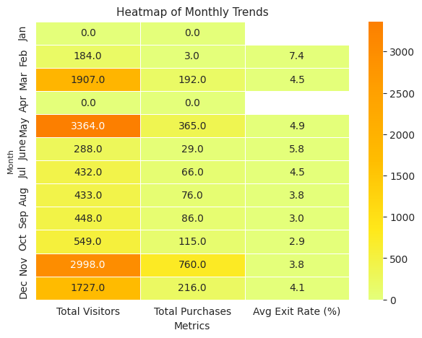
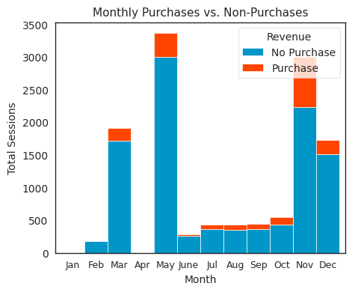

Figure 4.1B: Heatmap of Monthly Trends
Figure 4.1A: Histogram of monthly purchases vs non-purchases

The histogram in Fig 4.1A shows trends in monthly visitor data and purchase made. According to the data, May and November are the two months with the highest sales volume. Moderately high purchases in both March and December could be due to seasonal purchase trends. From June to September, the number of visitors stayed the same, but purchase rates were low, indicating a decreased conversion rate during this time. These changes could be due to seasonal vacations and shifts in consumer preferences.
The revenue distribution heatmap in Fig 4.1B backed up the histogram, as it shows May and November generating the highest purchases of 3364 and 2998, respectively. The necessity to change marketing tactics to increase sales during months with poor conversion rates is evident from the low earnings during June and July. According to the exit rate metric, users who spend more time on the website browsing are more likely to make a purchase as it is evident that there are lower exit rates in months where high number of purchases were made.

4.1.2 Website Activities and Revenue
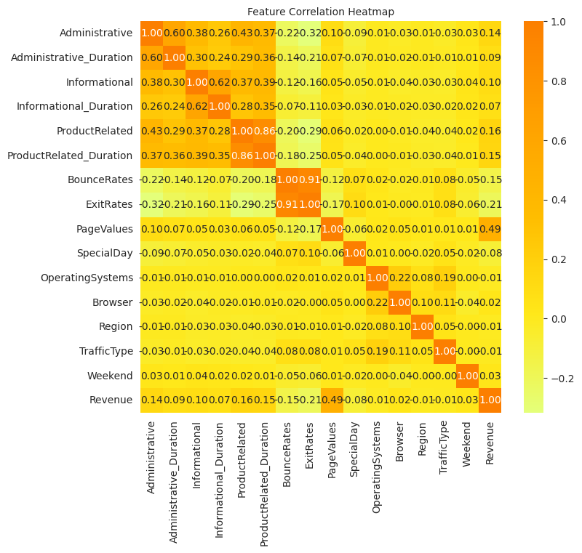

Figure 4.2 Correlation heatmap showing relationship between revenue and all other variables

The correlation heatmap of Fig 4.2 illustrates how website activity of users affects the prospects for likely purchase and revenue generation. As per the heatmap, customers who land on pages with valuable content are more likely to make purchases, which shows that PageValues have the strongest positive correlation of 0.49 with Revenue. Moreover, revenue has a negative correlation with Exit Rate and Bounce Rate, which means less conversion rate from users who do not explore pages related to products or leave the site quickly. To reduce early site departures that result in reduced conversion rates, better content engagement techniques should be created.
Although there is a slight positive correlation between purchases and the number of product-related pages people visited (0.16) and the amount of time they spent on these pages (0.15), this relationship is not statistically significant. According to negative correlation of -0.08 between Special Days and Revenue, there is little evidence between special events causing higher consumer spending. Weekend exhibits nearly no association with Revenue, indicating that weekend purchases do not substantially rise or fall.

4.1.3 Types of Visitors and Purchase Patterns
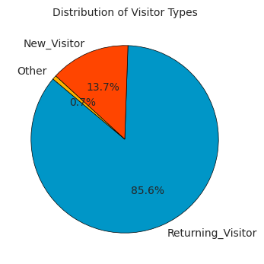
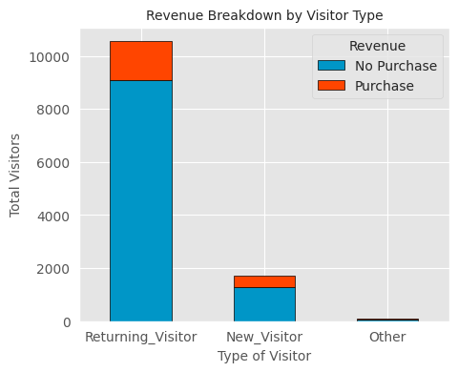

The Pie Chart in Fig 4.3A indicates that 85.6% of the visitors are returning users and 13.7% are new users.This proves a need for stronger retention strategies that offer exclusive offers or personalised recommendations to increase customer loyalty, because the high percentage of returning visitors contrasts with their lower conversion rate when compared to new visitors.
Even while returning users are the majority of session viewers, new visitors are bringing in more revenue through conversions. The rise in first-time visitor behaviour suggests that they are more likely to make impulsive purchases or to take advantage of new customer offers.
Figure 4.3A: Distribution of Visitor Type
Figure 4.3B: Revenue Breakdown by Visitor Type

4.1.4 Traffic Type Distribution
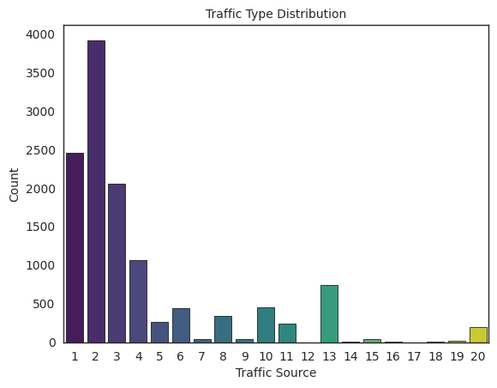
Figure 4.4 : Traffic Type Distribution
Fig shows majority of website visitors originate from traffic sources 1, 2, and 3. Marketing campaigns should concentrate their efforts on these top traffic sources while also looking into underutilised sources to expand customer access.
Traffic Source | Possible Interpretation
1 | Organic Traffic
2 | Direct Traffic
3 | Referral Traffic
4 | Paid search
5 | Social Media

Table 4.1: Traffic Sources of the website and their possible interpretations

4.1.5 Weekend Purchase trends
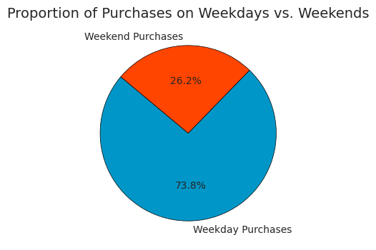
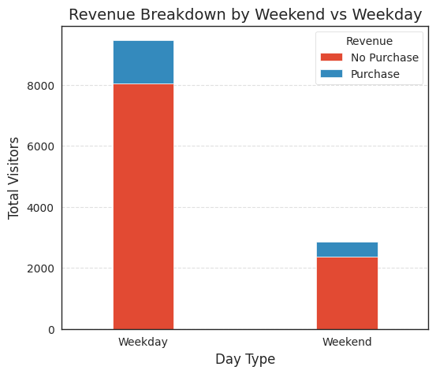

Figure 4.4B: Proportion of Purchases on
Weekdays vs Weekend
Figure 4.4A: Revenue Breakdown by Weekend vs Weekday

A comparison of revenue between weekdays and weekends reveals clear behavioural patterns: The store receives more visitors on weekdays than on weekends, but weekend visitors are more likely to make purchases.Although weekend visitors are still few in number, their intent to buy is stronger. The Feature Correlation Heatmap from Fig 4.2 supports this finding because the population of weekend shoppers has a lower exit rate than weekday shoppers, indicating that weekend shoppers make more purchases.
The weekend purchase pie chart from Fig4.4B shows that 26.2% of all transactions take place on weekends, whereas 73.8% of all transactions take place during the week. The dominance of weekday purchases and the high sales conversion rates on weekends suggest that particular weekend promotional strategies should be developed in order to optimise revenue.

4.1.6 Strategic Insights and Implications
- Creating more high-value pages: Since PageValues turned out to be the most
important feature, businesses should focus their efforts on optimising high-value sites. Pages with valuable content, such as product listings and checkout pages, must be visited with by users. Businesses need to put in place tailored recommendation systems that increase user exposure to specific pages. This is dealt with more in detail in the Overall Design Efficiency part of this dissertation.
- Reducing Bounce and Exit Rates: Both BounceRates and ExitRates are significant determinants of the buying decision. To boost user engagement and retention, website performance, content matching, and user interface design must all be improved.
- Increasing Customer Interaction Time: Higher conversion rates were found to be directly correlated with longer product page stays. By offering interactive product displays together with thorough descriptions and user ratings for longer product page durations, the company may improve user engagements.
- Personalized Marketing Campaigns: High-impact features can be targeted on those users indicating purchase-intent behaviours, such as those accessing high-value pages without making a purchase which will help firms achieve successful targeted marketing.
- Website Optimization for User Retention: Improving website speed, simplifying navigation, and incorporating personalised suggestion features are all important components of user retention-focused website optimisation since they increase engagement and conversion rates.
- AI-Powered Product Recommendations: Identifying high-impact traits makes it feasible to improve AI-based product recommendation systems through machine learning, enabling more customised product recommendations that increase user engagement and conversion rates.

4.2 Findings and Analysis of Machine Learning Model
The evaluators for this classification problem were chosen to be Precision, Recall, Accuracy, F1-Score and ROC-AUC metric. Model assessment with these metrics shows both predictive accuracy and balance between false positive and false negatives,

4.2.1 Comparative Analysis of five different prediction models
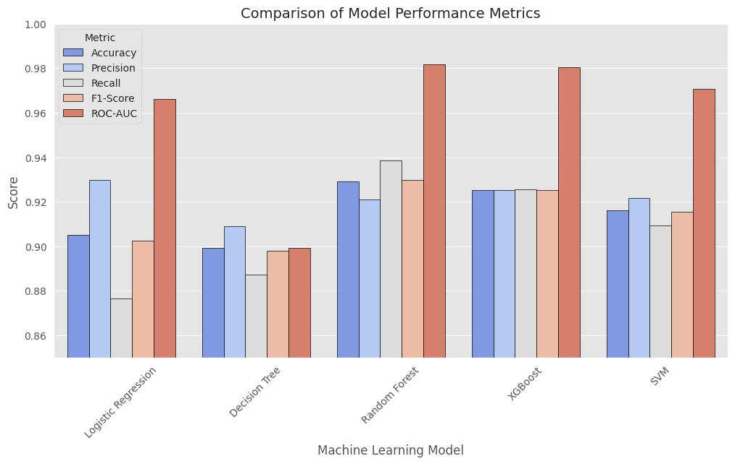

Figure 4.5: Comparison of five models and their performance metrics

The results confirmed that ensemble methods of Random Forest and XGBoost are more effective than simple models like Logistic regression and Decision trees in accuracy. Ensemble approaches produced better results as they help to uncover complex data patterns. One-Hot Encoding and log transformation techniques in the data processing might have optimised accuracy and stability in the models. Excellent precision-recall ratios were found in the top-performing prediction models, and they made sure there were least number of false positives and false negatives in the purchase behaviour prediction.
Another useful metric is the F-1 score which is calculated using the mean of Precision and Recall score. (Hand et al. 2021b)
Due to their superior performance on recall and ROC-AUC measures, Random Forest and XGBoost were shown to be the most effective models for the case in question. Together, SVM and logistic regression demonstrated great performance with balanced recall metrics and good precision. The Decision Tree model was the least preferred choice since it performed poorly due to overfitting and had the lowest ROC-AUC score. These evaluation findings show that Random Forest and XGBoost are among the ensemble models that work well for the classification task.

Model | Accuracy | Precision | Recall | F1-Score | ROC-AUC | Performance Summary
Random Forest | 0.929 | 0.920904 | 0.93858 | 0.929658 | 0.981598 | Best performer with top ROC-AUC and recall score
XGBoost | 0.925402 | 0.92518 | 0.925624 | 0.925402 | 0.980327 | Next best after Random Forest, well-balanced.
SVM | 0.916047 | 0.921693 | 0.909309 | 0.915459 | 0.970805 | Strong performer but computationally expensive.
Logistic Regression | 0.905253 | 0.929771 | 0.876679 | 0.902445 | 0.966250 | High precision and good at reducing false positives
Decision Tree | 0.899256 | 0.909046 | 0.887236 | 0.898009 | 0.899172 | Balanced but prone to overfitting.
Table 4.2 Evaluation Metrics for each of the five prediction machine learning models

4.2.2 Random Forest:
With an accuracy rate of 92.8 percent, Random Forest produced the best results in all 5 models. As the model correctly identified the majority of purchase instances, it had an exceptional recall rate of 94.0 percent. This model achieved great precision recall balance, as seen by its 92.9 percent F1-score. With a ROC-AUC of 98.1 percent, this model demonstrated its superiority in differentiating between buyers and non-buyers. Random Forest reduces the number of incorrect non-purchases while exhibiting the highest potential for overall prediction success.

4.2.3 XGBoost:
By providing higher accuracy together with improved recall and F1-score scores in purchase prediction tasks, XGBoost's evaluation results demonstrated that it performed well. In terms of performance, since XGBoost achieved an accuracy of 92.5 percent, it demonstrated a strong resemblance to Random Forest. The model produced exceptional classification results by achieving an equally balanced precision and recall of 92.5%. With a ROC-AUC value of 98.0 percent, the model nearly matched the performance outcomes of Random Forest. Based on this evaluation, XGBoost proves as a good replacement model with possible benefits.

4.2.4 Support Vector Machine
Support Vector Machine outperformed Decision Trees but was below Random Forest and XGBoost by a small margin, with an accuracy of 91.6 percent. Support Vector Machine achieved an outstanding result with a precision rate of 92.1 percent and a recall of 90.9 percent. Strong classification abilities can be detected by the value of 97.0 percent ROC-AUC. SVM is best suited for situations where the feature space is highly complicated, and it is also quite costly computational wise.

4.2.5 Logistic Regression
With a prediction accuracy of 90.5%, the use of Logistic Regression was a successful one. The model's high precision of 92.9% indicates that it can reduce the number of false positive predictions. The recall score of 87.6 percent showed where it lagged in being unable to identify several instances of actual purchases. The model's 96.6 percent ROC-AUC score proved that it can successfully distinguish between buyers and non-buyers. This will help in keeping marketing costs low by preventing product recommendations to customers who will not make purchases, therefore it performs better when false positives will be more costly.

4.2.6 Decision Tree
Despite achieving 90.0 percent accuracy, the Decision Tree model's accuracy was marginally lower than that of Logistic Regression. It gave an F1-score of 90.0 percent, which was due to the recall and a precision level of 89.2 and 90.7 percent respectively. Comparing the model to ensemble methods revealed an overfitting flaw that impacted its overall application rate. Despite producing simple interpretations, the model was unable to match Random Forest's performance.

4.3 Findings from Overall Design Efficiency

4.3.1 Exit Rates vs. Informational and Administrative Pages
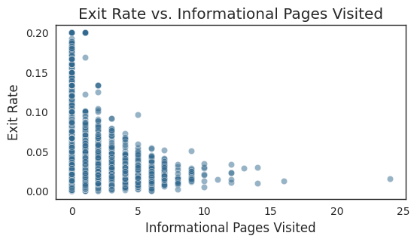
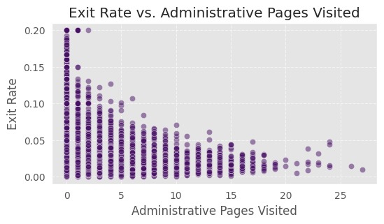

Figure 4.6B: Exit Rate of Administrative Pages Visited
Figure 4.6A: Exit Rate of Informational Pages Visited

Users who visit more administrative and informational pages have lower exit behaviour rates, according to Fig 4.6A and 4.6B. Visitors who stay on the pages longer are more likely going to find related products, whereas those who leave early might run have into issues with the content or might have failed to get the information they needed.

4.3.2 Exit Rates vs Product Pages
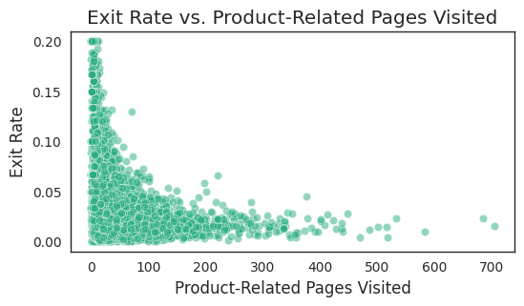

The results of the evaluation of product-related pages are almost similar. Users that view a small number of product pages have the greatest exit rates, which fall as users interact with more product pages. Users who browse more on the website stay for longer time on it, therefore there needs to be research for better product information and navigation on the website, which will encourage them to stay on the site longer rather than leaving.
Figure 4.7 : Exit Rate for Product Related Pages Visited

4.3.3 Page Values Across Different Page Types
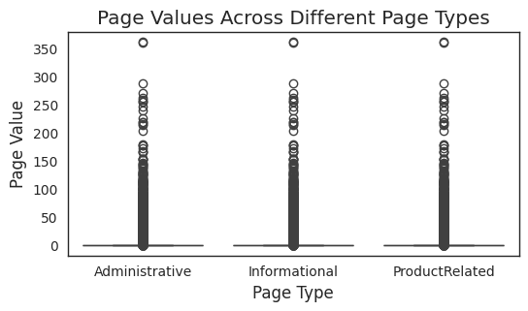

Figure 4.8 : Page Value variable compared with all three types of pages: Administrative, Information and Product Related.
The purpose of evaluating page values is to determine which page types result in the highest levels of interest from users and conversion. According to the data gathered, product pages have the highest engagement value. Because visitors to product pages are more likely to make purchases, these pages offer the most value. The presence of outliers in various page categories indicates that certain pages from every category may generate significant conversions that requires further examination.
As these operate as crucial guides for consumers completing transactions, several non-product pages in the Administrative and Informational category generate higher than anticipated levels of engagement Strong support for user engagement, which results in conversions, is provided by a well-structured FAQ page, a clear shipping policy, and easy-to-use login and checkout processes. Finding successful outlier pages gives insight into how to enhance related website components. Further examination of user interaction data from clickstreams and maps will uncover the factors that contribute to these selected pages improved performance, allowing for their effective use or adaptation across the website.

4.3.4 Breakdown of Page Visits by Purchase Behaviour
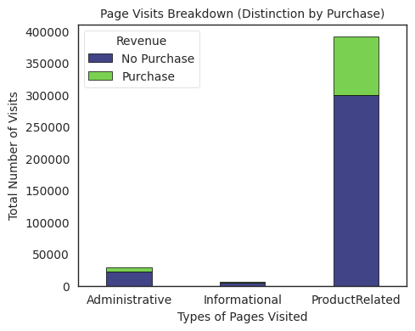

While most visits to administrative and informational pages end in no transactions, the majority of customers who make purchases do so via product-related pages. In addition to streamlining checkout processes and reducing the number of barriers that could lead customers to abandon the process, businesses should focus on enhancing the display formats of product pages.
Figure 4.8 : Page Visits Breakdown by Purchase

4.3.5 Visitor Type Distribution
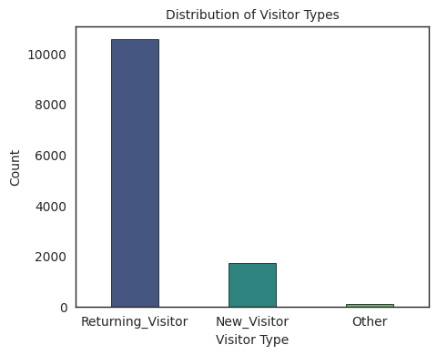

Figure 4.9 : Distribution of Visitor Types

The distribution analysis segment separates visitors into Returning Visitors and New Visitors along with Other Categories for evaluation. The largest group of customers engaging with the platform consists of Returning Visitors owing to strong customer loyalty. The lower New Visitors count demonstrates that the company needs to enhance its marketing strategies alongside better onboarding procedures and first-time user retention programs to gain and maintain new customers.

4.3.6 New Insights after Feature Engineering
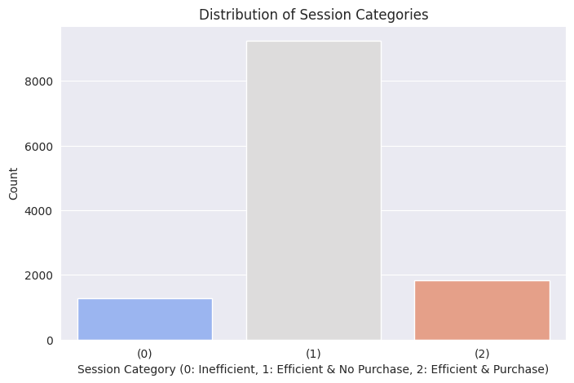

Figure 4.10 : Distribution of new variable “Session Categories”.
0: Inefficient session, 1:Efficient and No purchase, 2:Efficnet and Purchase

A significant portion of user sessions fall into category 1, in which consumers effectively navigate the website but do not complete purchases. Users can find the information they need on the website, but technological issues prevent them from completing transactions. Few users are able to complete a transaction through the website, hence Category 2 (efficient and purchase) accounts for a small percentage of all sessions. Although most visitors navigate the website effectively, the modest number of category 0 sessions suggests that they may need higher purchase incentives.

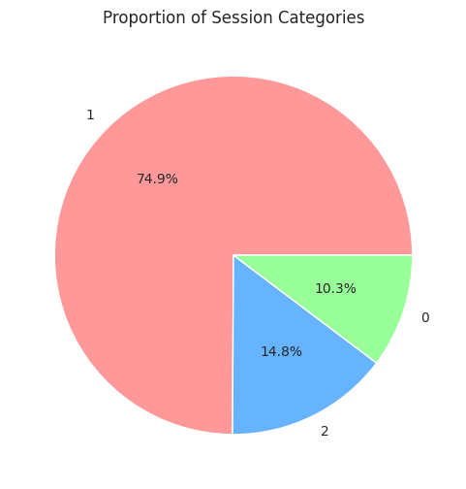

Figure 4.11 : Proportion of new variable “Session Categories”

A pie chart uses percentage data to visually represent the prevalence of session categories. 74.9% of sessions fall into category 1, indicating that users are able to successfully traverse the website without making a purchase. Since they only account for 14.8% of all sessions, category 2 purchases are not very successful; nonetheless, the high level of engagement necessitates increased conversion effectiveness. According to the data analysis, just 10.3% of customers experience ineffective website navigation (category 0). Therefore,companies should focus on improving the purchasing process rather than making major changes to the usability of the system.

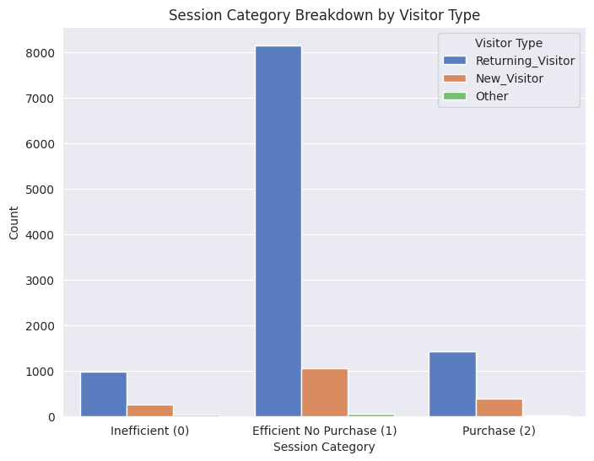

Figure 4.12: Session Category Breakdown by Visitor Type

The distribution of session categories is determined by visitor type using the stacked bar chart analysis. The majority of website sessions that fall under category 1 (effective but no purchase) are carried out by users who have visited the website before. These users come back to the website to view content but do not complete transactions. According to the histogram, new visitors are less likely to employ this pattern since they require easier checkout procedures or extra purchasing incentives. When it comes to category 2 transactions, returning visitors exhibit higher purchase rates than new visitors. In order to increase the amount of interested clients who become paying customers, it is necessary to address user concerns over prices, build confidence, and expedite the checkout process.

4.4 Justification and Discussion

4.4.1 Purchase Prediction Model
Similarity with existing Literature | New insights and differences
Like this paper, Kashyap and Nayak (2018) and Zhang (2025) showed that XGBoost ensemble approaches outperformed simple models in the analysis of complicated and non-linear buying patterns. Moreover, reiterating what this paper analyses, Koehn et al. (2020) also believes that product-related interactions and page values are good predictors of purchase intention as they enhance user engagement elements. Unlike Haider and Yesilda (2022), this paper's model avoided the computational complexity associated with employing CNNs and visual image data while still achieving good interpretability. Both Cheng-Ju Liu et al. (2020) and Borja Requena et al. (2020) noted the same thing this research found about how time-based and page depth behavioural variables outperformed simple click counts for prediction purposes. | While the majority of earlier studies focused solely on model performance, this study integrated comprehensive descriptive analytics (such as monthly trends, visitor type, and traffic sources) between organic user behaviour and machine learning outcomes. The study found that weekend customers, despite being less in number , had more intentional purchasing behaviours, while new visitors had greater conversion rates. Although user segmentation by clustering has been studied by Carmona et al. (2012) and Zavali et al. (2023), this study coupled predictive modelling with clustering insights to produce useful campaign strategies. This research gave a more balanced view of performance needs alongside interpretability and provides a comprehensive understanding of e-commerce user actions, combining traditional data examination with supervised algorithms.

4.4.2 Overall Design Efficiency
Similarity with existing Literature | New insights and differences
This paper demonstrated that consumers favour websites that make information easily available, which is consistent with the findings of Tan and Wei. Moreover, Groth and Haslwanter provides evidence in favour of this papers idea of usability metrics, demonstrating that effective functionality is a more significant component influencing user performance than only visual appeal. Finding a balance between basic designs that highlight interactive features and adaptable user interfaces is essential for creating great user experiences, similar to research findings of Auger (2005). | This paper does not focus only on controlled usability tests or qualitative user feedback like other literature, but it integrates a data-driven approach with direct measures of user interaction and session patterns.  The analysis integrates quantitative user interaction data, which current researches have also done, to qualitative usability testing of the website.This approach illustrates the importance of design simplification and pinpoints the precise steps at which consumers abandon or complete their journey. Since this paper is universally applicable across different markets and user groups, its findings are applicable regardless of regional circumstances, unlike some researches like the Fuzzy DEMATEL Approach of Gaur et al. The study connects practical usability formats to the wide range of advantages of data mining for dynamic website creation and combines user analytics with session-level observations to generate actionable steps that professionals in the industry can modify for various sectors.

Chapter 6: Recommendations and Challenges

6.1 Recommendation on findings
Firstly,the analysis forms the basis for several suggestions that can improve the user experience and the operational effectiveness of websites. Companies must first optimise their product pages to produce visually appealing sites that are always simple to navigate and have clear call-to-action buttons to assist customers in completing their purchases. Reducing unnecessary pop-ups and overly frequent links that divert users from these websites will increase conversion rates and user engagement.
Secondly, despite navigation on the website for a reasonable period of time, many customers do not complete their orders. Customers had trouble checking out, therefore, access to guest checkout and fewer form fields are needed to make the checkout process more efficient. The information gathered shows that although users who return to the website engage with the content, they do not complete their purchases. Personalised product recommendations, free shipping, and time-limited discounts will encourage customers to finish their purchases.
Moreover, companies must try to shorten the time visitors must spend on administrative and informational sites. The necessary pages must provide users with prompt, effective solutions without compromising usability. Users can reduce the amount of time they spend manually navigating with the inclusion of improved search functionality, short FAQ information section, and chatbot support.
As consumers tend to abandon pages that take too long to load, optimising page load time is crucial. To ensure seamless user interface performance, businesses must use caching techniques and image compression alongside with content delivery networks (CDNs). When pages load quickly, users prefer to stay on them longer and are more interested in looking at more products.
Since product pages display the most client contact, improved designs combined with clearer information result in higher conversion rates. High quality photos with thorough text descriptions and reviews should be shown in the most visible areas of the page. Conversion rates are increased when "Buy Now" and "Add to Cart" buttons are positioned strategically to increase the visibility of CTAs (calls to action).
Additionally, the likelihood of new users making purchases on the website is relatively low, so retailers should offer a clear navigating process that displays site information and offers initial buyer price reductions, new user engagement and conversion rates will increase.
Businesses can recover sessions that were effective but did not lead to purchases by implementing retargeting strategies through email-based marketing and advertising techniques. Personalised product recommendations combined with abandoned cart emails are an effective way to accomplish this.
One way to find out the cause of purchase hesitancy by customers is through customer feedback and UX testing. By using heatmaps to analyse clicks and patterns, businesses can find issues and navigational challenges that customers face when browsing .
Businesses can build customised browsing experiences for customers who return to the website by implementing personalisation tactics. This can be done by using historical user data to provide tailored product recommendations together with dynamic content, increasing consumer engagement and opening up new sales channels.
To improve the overall experience, regular A/B testing is necessary to allow users to assess webpage layouts and design aspects and analyse their responses. Websites can adapt to visitor behaviour patterns and industry trends through the ongoing iterative process, improving corporate performance and efficiency levels.

6.2 Recommendations for Future Research
Future research needs to focus on obtaining detailed data because this would enable more sophisticated sequential analysis through real-time user action timestamp logging. Moreover, the analysis becomes more focused when researchers incorporate complete traffic source records together with regional data since these elements show how different locations and entry points influence user activities. Future research needs to analyze device-type information more extensively since it would help researchers assess how interface designs perform on mobile and desktop systems. When basic clickstream data is improved by combining A/B-testing results with marketing performance indicators and user information we obtain more detailed modelling potential and increased recommendation customization possibilities. Feature-attribution techniques that offer model explanations should be implemented into the system to make predictive results more understandable so stakeholders can develop action plans and trust the recommendations

6.3 Challenges
Initially, the study’s goal was to conduct data mining technique of Market Basket Analysis, however the lack of time-stamp data could not make this possible. This study was unable to gain direct system access to the website server or associated systems, therefore crucial data on the geographic region or traffic source could also not be obtained. Because crucial location data was missing from the dataset, the study was unable to identify visitor locations or their behavioural responses. Access to these specific bits of data may have led to a deeper investigation and more useful recommendations about targeted advertising, mobile layout optimisation, and website design. Our ability to do a thorough study of the site's overall performance and to conduct a data mining approach of Market Basket Analysis was limited by the absence of specified data.

Chapter 7: Conclusion
The primary goal of this research was to forecast e-commerce purchasing trends by analysing machine learning applications on clickstream information. To illustrate sophisticated techniques for comprehending digital user behaviour, the study primarily looked at how unprocessed data can be transformed into structured datasets.
Since improved predictive capabilities yield significant value, the main motivation behind this research was the recognition of the competition in the digital commerce environment. The dissertation described how the use of models in real-world applications goes beyond theoretical frameworks to facilitate the creation of marketing strategies, website improvements, and decision support.
Regarding the identification and use of patterns in user interactions, the study offered some crucial findings. As its primary basis, feature engineering turned out to be one of the most important for accurate prediction. The feature of Session categories, Bounce Rate, Exit Rate and Page Values were among the advanced features that improved data resolution. By training models with these characteristics, factors like duration of stay on product related pages and checkout pages can identify real purchasing signals.
The performance of several learning strategies was better than that of single strategies. Random Forests and XGBoost yielded the best accuracy combined with recall and precision outcomes, which resulted due to from their capacity to comprehend intricate non-linear connections. The majority of the time, user behaviour patterns diverged from both uniform and linear distributions, which ensemble learning models used by integrating numerous decision boundaries. The findings show why different and unpredictable user behaviours that arise in e-commerce platforms must be addressed by effective models.
The importance of sequence detection techniques and highest predictive power was demonstrated by a third finding between product views and time-based variables. Customers who look at things for a short time have a great deal of curiosity, but those who look at them for a longer period of time and then return exhibit meticulous comparison behaviour. Because it demonstrated how users transitioned between different page types, the chronological modelling structure demonstrated how user intent evolved over time. Sequence and duration have a significant impact on online browsing behaviours, which should not be disregarded since they have a direct impact on the quality of model performance.
The results of the study showed how important it became to conduct multiple model experiments. Even the most accurate techniques that were tested still required frequent updates to maintain peak performance. When a corporation makes changes to its product offerings, interface designs, or promotional techniques, the significance of various product attributes shifts.

7.1 Contribution to Literature
This dissertation's is a part of the growing clickstream analysis research, which establishes itself as the main source of intelligence on digital commerce. Beyond merely collecting large amounts of user data, the deliberate design of engineered variables enables reliable insights into user intent. Through data cleaning, feature engineering, and model evaluation, the study creates a reliable path that enables retailers and businesses to unlock the latent potential of user interaction logs.
Performing broad empirical tests using multiple algorithmic approaches is the study's primary accomplishment. In contrast to earlier research that focused on individual models, the current study took a holistic approach to comprehending a variety of forecasting methodologies. In order to show that specific ensemble approaches produce better and more dependable outcomes, particularly when working with large-scale clickstream data sets that contain complex patterns, the dissertation assessed performance based on Accuracy, the F1 score, and the AUC.
The dissertation's repurposing of clickstream data beyond its usual use as a collection of anonymous click sequences was another significant aspect. Through a variety of analyses of sequential order and time aspects along with user environment data, the study highlights the dynamic nature of online purchasing.
The study's focus on useful implementation strategies addressed a void in scholarly research. Businesses can use the study’s explanation of several approaches for handling data discrepancies, user interest changes, and session anomaly patterns to e-commerce applications. Data science requires practical theoretical analyses that uphold predictions based on actual use patterns and organisational goals, as evidenced by the application of academic research with industrial needs. The dissertation encourages the academic and business worlds to be connected through clickstream data as a platform for creating innovative algorithms. To develop sophisticated context-based solutions, new machine learning techniques like deep neural networks and graph-based approaches encompass the fundamental ideas studied.

7.2 Reflection
Data cleansing, feature engineering, and model testing techniques were all major parts of this dissertations study to prove how user actions are heavily influenced by website layout, promotional offers, and individual consumer preferences.
The study found that while predicting accuracy is still a challenging and ever-changing goal, advanced machine learning shows great promise for e-commerce. Professional teams of data scientists, domain experts, and user experience specialists can work together to show how important it is to collaborate in order to translate the unprocessed results of predictive analysis into solutions that can be understood.
In the end, this dissertation confirms how machine learning can revolutionise online retail. Based on its capacity to uncover pattern structures in clickstream data and demonstrate how every contact contributes to a larger decision-making process that permits more investigation and improvement, the current study offers research value. This study will provide the groundwork for additional research and real-world applications that help businesses thrive in digitally reliant markets.

References
- Auger, P. (2005) The Impact of Interactivity and Design Sophistication on the Performance of Commercial Websites for Small Businesses. Journal of Small Business Management 43 (2), 119–137.
- Baumann, A., Haupt, J., Gebert, F. and Lessmann, S. (2018) The Price of Privacy. Business & Information Systems Engineering 61 (4), 413–431.
- Blockeel, H., Devos, L., Frénay, B., Nanfack, G. and Nijssen, S. (2023) Decision trees: from efficient prediction to responsible AI. Frontiers in Artificial Intelligence 6, .
- Bradlow, E.T., Gangwar, M., Kopalle, P. and Voleti, S. (2017). The Role of Big Data and Predictive Analytics in Retailing. Journal of Retailing, 93(1), pp.79–95.
- Bucklin, R.E. and Sismeiro, C. (2009) Click Here for Internet Insight: Advances in Clickstream Data Analysis in Marketing. Journal of Interactive Marketing 23 (1), 35–48.
- Carmona, C.J., Ramírez-Gallego, S., Torres, F., Bernal, E., del Jesus, M.J. and García, S. (2012) Web usage mining to improve the design of an e-commerce website: OrOliveSur.com. Expert Systems with Applications 39 (12), 11243–11249.
- Chen, K. (2020) An Online Retail Prediction Model Based on AGA-LSTM Neural Network. 2020 2nd International Conference on Machine Learning, Big Data and Business Intelligence (MLBDBI) IEEE.
- Chevalier, S. (2024) Global digital purchases by channel 2024. https://www-statista-com.brad.idm.oclc.org/statistics/861336/share-online-shopping-customers-vs-sales-by-platform/ Accessed 18 March 2025.
- Gallino, S., Karacaoglu, N. and Moreno, A. (2019) Whether Weather Matters: Impact of Exogenous Factors on Customers Channel Choice. https://link.springer.com/chapter/10.1007/978-3-030-20119-7_10#Tab7 Accessed 20 March 2025.
- Gaur, L., Agarwal, V. and Anshu, K. (2020) Fuzzy DEMATEL Approach to Identify the Factors Influencing Efficiency of Indian Retail Websites. https://link.springer.com/chapter/10.1007/978-981-15-3647-2_6 Accessed 23 March 2025.
- George, J.F. (2004) The theory of planned behavior and Internet purchasing. Internet Research 14 (3), 198–212.
- Gkikas, D.C. and Theodoridis, P.K. (2021). AI in Consumer Behavior. Learning and
Analytics in Intelligent Systems, 22, pp.147–176.
- Groth, A. and Haslwanter, D. (2015) Efficiency, effectiveness, and satisfaction of responsive mobile tourism websites: a mobile usability study. Information Technology & Tourism 16 (2), 201–228.
- Gupta, R. and Pathak, C. (2014) A Machine Learning Framework for Predicting Purchase by Online Customers based on Dynamic Pricing. Procedia Computer Science 36, 599–605.
- Gupta, S. and Joshi, S. (2022) Predictive Analytic Techniques for enhancing marketing performance and Personalized Customer Experience. 2022 International Interdisciplinary Humanitarian Conference for Sustainability (IIHC) IEEE16–22.
- Haider, W. and Yesilada, Y. (2022) Classification of Layout vs. Relational Tables on the Web: Machine Learning with Rendered Pages. ACM Transactions on the Web 17 (1), 1–23.
- Hakkal, S. and Lahcen, A.A. (2024) XGBoost To Enhance Learner Performance Prediction. Computers and Education: Artificial Intelligence 7, 100254.
- Hand, D.J., Christen, P. and Kirielle, N. (2021a) F*: an interpretable transformation of the F-measure. Machine Learning 110 (3), 451–456.
- Hand, D.J., Christen, P. and Kirielle, N. (2021b) F*: an interpretable transformation of the F-measure. Machine Learning 110 (3), 451–456.
- Kashyap, A. and Nayak, A. (2018) Different Machine Learning Models to Predict Dropouts in MOOCs. 2018 International Conference on Advances in Computing, Communications and Informatics (ICACCI) IEEE80–85.
- Koehn, D., Lessmann, S. and Schaal, M. (2020) Predicting online shopping behaviour from clickstream data using deep learning. Expert Systems with Applications 150, 113342.
- Lee, J., Podlaseck, M., Schonberg, E. and Hoch, R. (2001) Visualization and Analysis of Clickstream Data of Online Stores for Understanding Web Merchandising. Applications of Data Mining to Electronic Commerce Boston, MA: Springer US. 59–84.
- Lemon, K.N. and Verhoef, P.C. (2016) Understanding Customer Experience Throughout the Customer Journey. Journal of Marketing 80 (6), 69–96.
- Leonov, Y., Nakonechnyi, Oleksandr, Khalimanenko, Viktoriia, Nikolaiko, Halyna and Heraimovych, Violeta (2023) Analysis of the Influence of Psychological Factors on Consumer behavior and the Decision-making Process. Economic Affairs 68 (3), .
- Naidu, G., Zuva, T. and Sibanda, E.M., 2023, April. A review of evaluation metrics in
machine learning algorithms. In Computer Science On-line Conference (pp.
15-25). Cham: Springer International Publishing.

- Natasia, S.R., Wiranti, Y.T. and Parastika, A. (2022) Acceptance analysis of NUADU as e-learning platform using the Technology Acceptance Model (TAM) approach. Procedia Computer Science 197, 512–520.
- Nitta, I., Ishizaki, R., Shingu, M., Nakashima, S., Maruhashi, K., Tolmachev, A. and Todoriki, M. (2021) Graph-based Massive Open Online Course (MOOC) Dropout Prediction using Clickstream Data in Virtual Learning Environment. 2021 16th International Conference on Computer Science &amp; Education (ICCSE) IEEE48–52.
- Office for National Statistics (UK) (2024) Great Britain: online retail month-on-month change by sector 2024. https://www.statista.com/statistics/1195913/uk-online-retail-growth-month-on-month-united-kingdom/ Accessed 20 March 2025.
- Oualid, C., Selma, D. and Soufyane, B. (2024) The Impact of Content Personalization on Customer Engagement and Market Risks of E-Stores. Financial Markets, Institutions and Risks 8 (3), 37–56.
- Patel, A. (n.d.) Online Shoppers Purchasing Intention Dataset. https://www.kaggle.com/datasets/imakash3011/online-shoppers-purchasing-intention-dataset/data Accessed 26 March 2025.

- Requena, B., Cassani, G., Tagliabue, J., Greco, C. and Lacasa, L. (2020) Shopper intent prediction from clickstream e-commerce data with minimal browsing information. Scientific Reports 10 (1), 1–23.
- Sakalauskas, V. and Kriksciuniene, D. (2024) Personalized Advertising in E-Commerce: Using Clickstream Data to Target High-Value Customers. Algorithms 17 (1), .
- Sakar, C.O., Polat, S.O., Katircioglu, M. and Kastro, Y. (2018) Real-time prediction of online shoppers’ purchasing intention using multilayer perceptron and LSTM recurrent neural networks. Neural Computing and Applications 31 (10), 6893–6908.
- Selerity (2020) Deciding on the best approach to data analysis. .
- Tan, G.W. and Wei, K.K. (2006) An empirical study of Web browsing behaviour: Towards an effective Website design. Electronic Commerce Research and Applications 5 (4), 261–271.
- Tufail, S., Riggs, H., Tariq, M. and Sarwat, A.I. (2023) Advancements and Challenges in Machine Learning: A Comprehensive Review of Models, Libraries, Applications, and Algorithms. Electronics 12 (8), .
- Wen, Z., Lin, W. and Liu, H. (2023) Machine-Learning-Based Approach for Anonymous Online Customer Purchase Intentions Using Clickstream Data. Systems 11 (5), .
- Zavali, M., Lacka, E. and de Smedt, J. (2023) Shopping Hard or Hardly Shopping: Revealing Consumer Segments Using Clickstream Data. IEEE Transactions on Engineering Management 70 (4), 1353–1364.
- Zhang, J. (2025) Enhancing Predictive Models in E-Commerce: A Comparative Study Using XGBoost Across Diverse Scenarios. ITM Web of Conferences 70, 02014.
- Zhili Zhang, Changgeng Guo, Shu Yu, DeYu Qi and Songqian Long (2005) Web prediction using online support vector machine. 17th IEEE International Conference on Tools with Artificial Intelligence (ICTAI’05) IEEE6 pp. – 456.

Appendix

Research Proposal
INTRODUCTION
E-commerce is among the fastest-evolving industries, with consumers increasingly preferring to buy most of their products online. With the internet revolution, the surge in retail, promotion, and daily data generation has reached a level where marketers can no longer handle it using traditional statistical methods. This has led to the emergence of Big Data Analytics and Artificial Intelligence, which has brought about predictive analytics, including machine learning. ( Gkikas and Theodoridis, 2021)
Predictive analytics is a subset of business intelligence in the retail industry, concerned with foreseeing future trends. (Bradlow et al., 2017). The problem in today's retail world is that companies have data, but they find it difficult to forecast user behavior in real time, despite the fact that doing so will greatly increase their conversions. Retailers have access to "Big Data," but implementing it to boost company performance still presents significant challenges. (Bradlow et al., 2017)
Research Aims
The goal of this research is to create a classification model based on online session variables in order to forecast e-commerce purchasing behavior. The main goals of this study are to:
- Create a machine learning model that uses user session data to forecast if a purchase will be completed.
- Determine which session parameters—such as page type, bounce rate, and time spent on site—are most indicative of a purchase being completed.
- Provide a real-time deployment approach that e-commerce platforms may use to optimize their marketing and conversion efforts.
Research Questions
- What aspects of the session are most indicative of the completion of an online purchase?
- To what extent do machine learning models help in predicting e-commerce sales?
- Is it possible to apply an efficient machine learning model in real time for purchase prediction?
This research closes a gap in the literature by concentrating on session-based characteristics—an area that has received less attention in earlier research—to forecast user purchasing behavior. This project intends to provide e-commerce companies with actionable information using a real-time categorization model. These insights will enable them to improve personalization efforts, target marketing campaigns, and eventually increase conversion rates.
A customer's online activities on a website and click-stream data can collectively help do micro-segmentation, dynamic pricing, and personalized promotions. These insights can be derived using tree-based methods, which enable the identification of complex interactions and interrelations. (Bradlow et al., 2017)
LITERATURE REVIEW
Firstly, it is important to understand and review existing studies on predictive analytics in e-commerce, focusing on how businesses use machine learning to understand customer behavior. Predictive analytics uses current data to create predictions about what might happen in the future using a variety of techniques, including statistical algorithms, data mining, and machine learning.
These predictions help businesses develop and put into practice more effective sales and marketing strategies, such as converting new visitors into customers and increasing customer engagement. Moreover, they help to identify what type of promotions are suitable for their target audience. (Usmani et al., 2017). Since there is no direct communication between the customer and the seller, it has become difficult to forecast the intention of an online shopper to make a purchase. However, it can be anticipated by analyzing the customer's historical data and intended purchases. (Kabir, Ashraf and Ajwad, 2019)
Secondly, we need to understand Analytics Metrics and how they are useful for any e-commerce business. As per the paper, “Conceptual model for obfuscated TRUST induced from web analytics data for content-driven websites” written by Singal and Kohli, the most important metrics are “ Bounce rate ” , “ Dwell time ” , “ Website quality ”, “Overall traffic volumes”, and “Percent new visitors”. As per this journal, the definition of bounce rate is not fixed, as Google Analytics considers it “as number of single page visits” but another source claims that it is simply “the percent of traffic that stayed on your website for fewer than 10 seconds”. Dwell time is the time a user spends on a specific page and monitoring page dwell time helps a business analyze the discrepancies between the kind of information people are looking for and what is being delivered to them. Additionally, it helps categorize the kinds of pages that visitors read, which makes it easier to assess the worth of pages in relation to user conversion. This research paper is going to be using 2 of these more important metrics: bounce rate and dwell time, alongside other metrics.
Thirdly, special events, like Black Friday, Mother’s Day or even weekends, influence purchase behavior of online customers. Understanding them is important so retailers can know which products and when those products are most in demand. Research dedicated to consumer spending habits during holidays or special occasions was done by Swilley and Goldsmith in 2013. They tried to find out when and why customers shop more during holidays so that they could help businesses come up with better or personalized marketing techniques for these specific time periods. This research paper will use data that shows if the customer visited on a special day or even the weekend, as these metrics can be major indicators of their shopping patterns.
Moreover, the type of machine learning technique that is to be used depends on the type of analysis and data. A number of machine learning techniques are used in e-commerce prediction analysis such as logistic regression, random forests, and gradient boosting. A Machine learning function called classification places objects in a collection into certain groups or classes. Classification aims to accurately predict the target class label in the data set. The pre-processed data can be used on a variety of statistical approaches and data mining tools to find intriguing patterns. (Usmani et al., 2017)
There is still a need for real-time machine learning as compared to traditional batch machine learning. Real time data models are more advanced in the sense that they are always taking in new data and evolving with it. These can also be trained again and again on new data, which makes it very accurate and ideal for prediction. Taking the case of retail and e-commerce customers, the businesses must take action in real- time as well. They have to study the customer interaction and offer them recommendations and promotions as they are browsing on the page. There are multiple benefits but less has been done on this because of how much it costs in terms of time and money, and how complicated it can become.(Rosam, 2023)

PROPOSED METHODOLOGY

Research Design
The main objective of this research is to predict an e-commerce website customer's likelihood of completing a purchase using online shopping session variables. According to the research question in hand and the task being of a binary nature, a machine learning model of classification would be appropriate. Using machine learning, we can analyze and make sense of complex data to find patterns, leading to accurate forecasts based on past trends. This research will be done using supervised learning since the dataset has labeled instances.
As supervised learning can handle large data volumes, identify non-linear correlations between session variables and offer real-time insights into user behavior, it is very useful in e-commerce. We can develop an algorithm that forecasts future user behavior based on characteristics like page visits, bounce rates, and product interaction by training a model on past data.
Dataset
The dataset that will be used in this research is a public dataset available on Kaggle as “Online Shoppers Purchasing Intention Dataset”. It has 8 categorical attributes and 10 numerical attributes. The type of page a specific user visited is indicated by key characteristics like "Administrative," "Product Related," and "Informational," while some analytics were derived from Google Analytics such as, "Bounce Rate," "Exit Rate," and "Page Value."
Moreover, variables like "Special Day" and "Weekend" will help us understand how user behavior is affected by the time of the year or month , while categorical variables like "operating system," "browser," "region," and "visitor type" will help understand the user demographics more. Whether or not the user completed a purchase will be indicated by the class label, which is the "Revenue" attribute.

Data Preprocessing
Before the data is ready for our model, some preprocessing steps will have to be performed to ensure data quality and model accuracy is maintained.
Firstly, the missing values will have to be dealt with, as the performance of a model might be negatively impacted by missing values. Imputation(substituting missing numerical values with the median or mean) and other methods to get rid of partial records will be used.
Secondly, machine learning techniques are affected by the size of the features and to solve this, feature scaling will be done on attributes like "Administrative Duration" and "Product Related Duration” using techniques like Min-Max scaling or standardization. This will make sure that all numerical characteristics are on a scale that can be compared.
Next, Categorical Variables will have to be encoded. The dataset has Categorical variables, such as “browser,” “region,” and “visitor type,” which will be transformed into numerical format using techniques like one-hot encoding.

Model Selection
Several machine learning methods will be tested in order to identify the most accurate model for predicting the completion of a purchase.
Logistic Regression: This model will serve as the basic model from which the analyses will start. It will be useful for finding the linear correlations between the session attributes and purchase probabilities because of its interpretability and simplicity. It gives good results when the outcome is binary: customer buying or not buying on the e-commerce website. It is a well-liked probability based classification method.( Sarker, Kayes and Watters, 2019).However, the non-linear interactions might not be accurately represented by this method.
Furthermore, Decision trees will be used as well, which is another classification method.
A classification analysis will be done using Support Vector Machines (SVM).It is majorly used for predictive analysis. This is also a binary classifier and uses the construction of a hyperplane.( Sarker, Kayes and Watters, 2019)

Training and Testing
The split of the dataset will be 80/20: 20% of the dataset will be set aside for testing, while the remaining 80% will be used to train the models. This 80/20 split gives the model enough information to enable it to train efficiently, while also helping us to test its accuracy on new unobserved data.
Evaluation Metrics
After a model has been created and tested, the next step is to check how accurately it is performing. There are a number of performance metrics that are used for that.
Firstly, a confusion matrix will be used as it is the simplest way of calculating precision. It is a 2 by 2 matrix and tells us about precision, sensitivity, accuracy, and F1 Score. Precision will help us know how many predictions were correct, sensitivity helps us understand how accurately the model predicts True positives. Similarly, accuracy tells us how many predictions were correctly identified from the test dataset. (Naidu, Tranos Zuva and Elias Mmbongeni Sibanda, 2023)

Software and libraries
The programming language that this project will use will be python and the key libraries it will use are:
scikit-learn for logistic regression, random forests, and various preprocessing techniques.
Pandas and NumPy for data manipulation and
Matplotlib and Seaborn for visualizing data and interpreting the model results.

CONCLUSIONS
Certain characteristics, such as Page Value and Bounce Rate, are important indicators of whether a user completes a purchase, based on the suggested analysis and methodology. These characteristics provide important insights into purchase intent by directly representing user engagement and behavior during a session. Furthermore, user behaviors and activities change according to the day they are accessing the website on. For example, on certain special days like Mother’s day or valentine’s day, user conversions and purchases might be higher than usual.
The results of this study can help e-commerce businesses improve and become more efficient marketers. These businesses can tailor their marketing tactics according to what the real-time predictive models suggest. This means certain users with a higher probability of buying can be offered personalized incentives or promotions. Conversion rates and total sales could be significantly enhanced by these strategies.
Additionally, by determining which product categories and web pages are most important in the decision-making process, these models can assist businesses in improving the user experience. This allows them to better target marketing efforts and improve website navigation.
To further increase the accuracy of purchase predictions, future research should focus on using more insightful attributes such as mouse movements and time of day. Furthermore, testing with more sophisticated machine learning methods, such deep learning models, might provide even higher prediction accuracy.

References

Bradlow, E.T., Gangwar, M., Kopalle, P. and Voleti, S. (2017). The Role of Big Data and
Predictive Analytics in Retailing. Journal of Retailing, 93(1), pp.79–95.
doi:https://doi.org/10.1016/j.jretai.2016.12.004.

Gkikas, D.C. and Theodoridis, P.K. (2021). AI in Consumer Behavior. Learning and
Analytics in Intelligent Systems, 22, pp.147–176.

Kabir, M.R., Ashraf, F.B. and Ajwad, R. (2019). Analysis of Different Predicting Model for
Online Shoppers’ Purchase Intention from Empirical Data. 2019 22nd
International Conference on Computer and Information Technology (ICCIT).
doi:https://doi.org/10.1109/iccit48885.2019.9038521.

Naidu, G., Zuva, T. and Sibanda, E.M., 2023, April. A review of evaluation metrics in
machine learning algorithms. In Computer Science On-line Conference (pp.
15-25). Cham: Springer International Publishing.

Rosam, M. (2023). The fundamentals of real-time machine learning. [online] Quix.io. Available at: https://quix.io/blog/fundamentals-real-time-machine-learning [Accessed 7 Oct. 2024].

Swilley, E. and Goldsmith, R.E. (2013). Black Friday and Cyber Monday: Understanding consumer intentions on two major shopping days. Journal of Retailing and
Consumer Services, [online] 20(1), pp.43–50.
doi:https://doi.org/10.1016/j.jretconser.2012.10.003.

Sarker, I.H., Kayes, A.S.M. and Watters, P. (2019). Effectiveness analysis of machine
learning classification models for predicting personalized context-aware
smartphone usage. Journal of Big Data, 6(1).
doi:https://doi.org/10.1186/s40537-019-0219-y.

Usmani, Z.A., Manchekar, S., Malim, T. and Mir, A. (2017). A predictive approach for
improving the sales of products in e-commerce. 2017 Third International
Conference on Advances in Electrical, Electronics, Information, Communication
and Bio-Informatics (AEEICB). doi:https://doi.org/10.1109/aeeicb.2017.7972409.

